**Response for Assignment 3.3**

Below screenshot shows the output of the program which takes user input and returns the longest word. Left side shows source code and right side shows output.

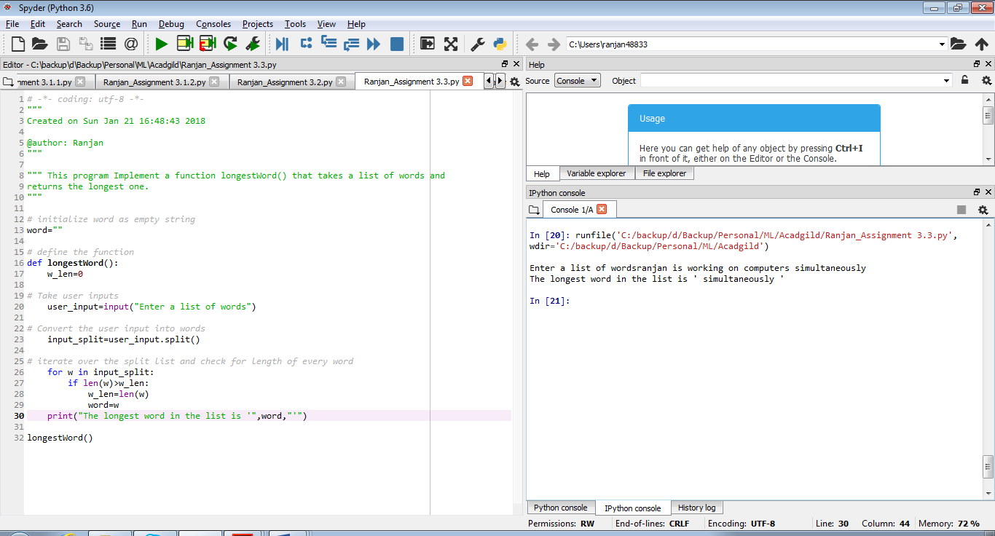

Source code

# initialize word as empty string

word=""

# define the function

def longestWord():

w_len=0

# Take user inputs

user_input=input("Enter a list of words")

# Convert the user input into words

input_split=user_input.split()

# iterate over the split list and check for length of every word

for w in input_split:

if len(w)>w_len:

w_len=len(w)

word=w

print("The longest word in the list is '",word,"'")

longestWord()